Title International Journal of Natural Science Studies and Development [Cambria, 16, Bold]
First Author¹*, Second Author²
^{1,2}Department, University, City, Country
*Corresponding author: author1@email.com

Abstract
This paper provides a template for preparing papers for electronic production of the Journal. A well-prepared abstract enables the reader to identify the basic content of a document quickly and accurately, to determine its relevance to their interests, and thus to decide whether to read the document in its entirety. The Abstract should be informative and completely self-explanatory, provide a clear statement of the problem, the proposed approach or solution, and point out major findings and conclusions. The Abstract should be 150 to 250 words in length. The abstract should be written in the past tense. Standard nomenclature should be used and abbreviations should be avoided. No literature should be cited. The keyword list provides the opportunity to add keywords, used by the indexing and abstracting services, in addition to those already present in the title. Judicious use of keywords may increase the ease with which interested parties can locate our article.
Keywords: Please Provide 3-5 Words Of Keywords Separated By Comas

INTRODUCTION
The introduction contains the background, theoretical basis, problems, problem solving plans and research objectives. The introduction is written using the letters Cambria, size 10 and spaced 1 and fist line 1 cm. Text is typed in a print area with margins from top, bottom, left, right made 2.5 cm. Paper size A4, 8.27 inch wide, 11.69 inch high. Layout: 0.5 inch header, 0.5 inch footer. Text does not need to be page numbered.

Article Type
Articles are original research articles or the results of reviews of previous articles. Articles can be written in Indonesian or English. The number of article pages is between 10 – 12 pages including a list of references. The systematics of writing research articles consists of title, author's name, institution and correspondence address, abstract, keywords, abstract, keywords, introduction, method, results and discussion, conclusions and suggestions, acknowledgments and list of references.
The systematics of writing a conceptual article (containing the results of a review) consists of the title, author's name, institution and correspondence address, abstract, keywords, abstract, keywords, introduction, main section, summary and list of references. The title of the article is written using Cambria font size 16, capitalized, bold, centered, consists of a maximum of 15 words and describes the contents of the manuscript.
The author's name is written using Cambria font size 12 without a title, the first name is abbreviated while the last name (surname) is not abbreviated. Author names from different agencies are marked using superscript after the name. Manuscripts are presented in a narrative manner (without numbering in front of the subtitles) and exposure in the form of subtitles is avoided. Formulas are written separately not in sentences and are numbered on the right. The formula is written using Microsoft Equation.

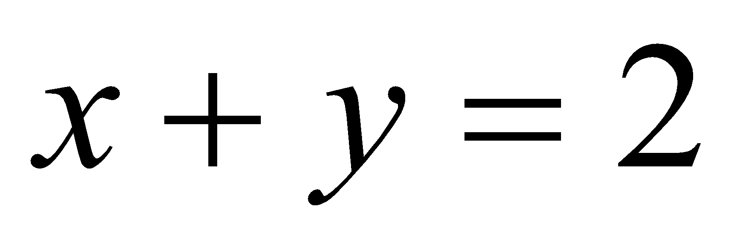 (1)

The image is inserted in the text box and the figure caption is placed under the image. Image captions are numbered and images must be referenced in the text. Image captions begin with a capital letter. Image captions that are more than one line are written using space 1. The image is painted with a line width of 1 pt and should have good contrast quality, can be seen in Figure 1.

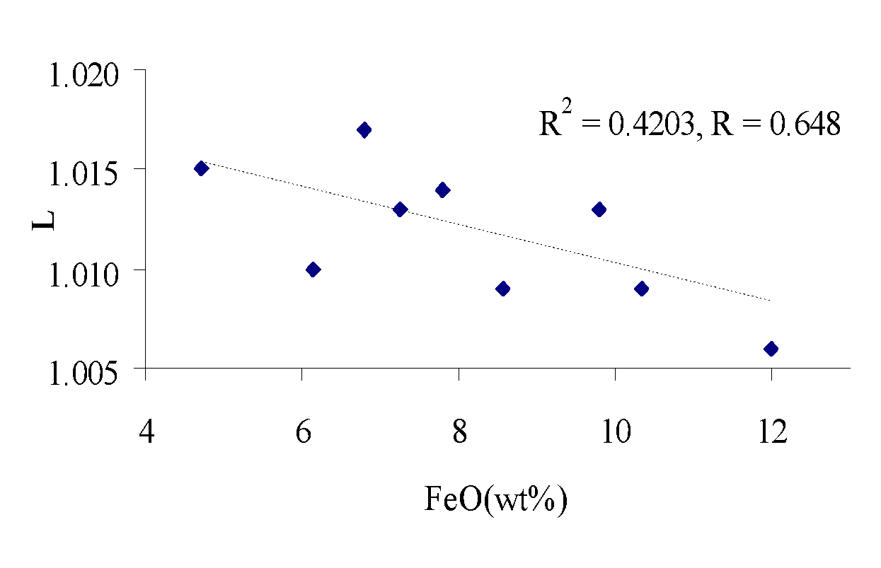
Gambar 1. Plots of lineation (L) and FeO content showing negative correlation.

METHOD
Contains how data is collected, data sources and data analysis methods

RESULTS AND DISCUSSION
Results
Results are the main part of scientific articles, containing: clean results without data analysis process, results of hypothesis testing. The results can be presented with tables or graphs, to clarify the results verbally. Discussion is the most important part of the overall content of scientific articles. The objectives of the discussion are: Answering research problems, interpreting findings, integrating findings from research into existing knowledge sets and developing new theories or modifying existing theories.

Discussion
The table is created with a line width of 1 pt and a table caption is placed above the table. Table descriptions that consist of more than 2 lines are written using 1 space. Table lines are prioritized only for horizontal lines while vertical lines are omitted. Can be seen in Table 1.
Table 1. Elemental processes of sampling sites
Site | TiO₂  (wt%) | Al₂O₃  (wt%) | MnO  (wt%) | MgO  (wt%) | Na₂O  (wt%)
GIJ | 0.5 | 16.4 | 0.19 | 2.74 | 3.00
GPW | 0.78 | 19.0 | 0.18 | 4.57 | 2.55
GSR | 0.62 | 16.3 | 0.17 | 3.09 | 3.09
KLB | 0.67 | 15.7 | 0.14 | 5.07 | 2.59
KSG | 1.90 | 17.1 | 0.15 | 3.79 | 3.33
PWH | 0.58 | 20.9 | 0.12 | 1.55 | 3.00
Total | 0.68 | 17.8 | 0.16 | 3.12 | 2.75

CONCLUSIONS AND SUGGESTIONS
Conclusion contains answers to research questions. Suggestions refer to the results of the research and are in the form of practical actions, state for whom and what the suggestions are intended for. Written in essay form, not in numerical form.
AI USAGE STATEMENT
In preparing this article, the author used [name of AI tool] to [describe the purpose of use, e.g., grammar checking and language editing]. All AI output has been reviewed, verified, and edited by the author. The author is solely responsible for the content, accuracy, interpretation, and conclusions of the article. AI Use Declaration: The author declares that no generative AI was used in the preparation, analysis, interpretation of data, or writing of this article.
AUTHOR CONTRIBUTION STATEMENT
For research articles with several authors, a short paragraph specifying their individual contributions must be provided. The following statements should be used “Conceptualization, X.X. and Y.Y.; methodology, X.X.; software, X.X.; validation, X.X., Y.Y. and Z.Z.; formal analysis, X.X.; investigation, X.X.; resources, X.X.; data curation, X.X.; writing—original draft preparation, X.X.; writing—review and editing, X.X.; visualization, X.X.; supervision, X.X.; project administration, X.X.; funding acquisition, Y.Y. All authors have read and agreed to the published version of the manuscript.” Authorship must be limited to those who have contributed substantially to the work reported
FUNDING STATEMENT
Please add: “This research received no external funding” or “This research was funded by NAME OF FUNDER, grant number XXX”.
CONFLICT OF INTEREST
Declare conflicts of interest or state “The authors declare that they have no known competing financial interests or personal relationships that could have appeared to influence the work reported in this paper.” Authors must identify and declare any personal circumstances or interest that may be perceived as inappropriately influencing the representation or interpretation of reported research results. Any role of the funders in the design of the study; in the collection, analyses or interpretation of data; in the writing of the manuscript, or in the decision to publish the results must be declared in this section. If there is no role, please state “The funders had no role in the design of the study; in the collection, analyses, or interpretation of data; in the writing of the manuscript, or in the decision to publish the results”.
ACKNOWLEDGEMENTS
If any, thanks are addressed to official institutions or individuals who have provided funding or have made other contributions to the research. Acknowledgments are accompanied by a research contract number.
REFERENCES
Writing a bibliography consists of the author's name, year of publication, article title, city name and publishing institution. Use Mendeley in writing a list of references. The list of references is sorted according to the first letter of the author's name (A-Z). The second word in the name is agreed upon as a surname. All references referenced in the text must be listed in the reference list. The reference list is prioritized for articles taken from the latest journals / publications no later than 5 years prior to article submission (paper submission). How to write references: surname and year (Alhakiki & Taufina, 2020).

Ary, D., Jacobs, L.C. & Razavieh, A. 1976. Pengantar Penelitian Pendidikan. Terjemahan oleh Arief Furchan. 1982. Surabaya: Usaha nasional
Arikunto, S. 1998. Prosedur Penelitian. Jakarta: Rinneka Cipta
Jawa Pos. 22 April 2008. Wanita Kelas Bawah Lebih Mandiri, hlm. 3
Donuata, P. B. (2019). Pengaruh Quantum Teaching Metode PQ4R Berdasarkan Keragaman Kecerdasan Terhadap Hasil Belajar Fisika. Jurnal Riset Dan Kajian Pendidikan Fisika, 6(1), 23–27. https://doi.org/10.12928/jrkpf.v6i1.11094.
Edriati, S., Hamdunah, H., & Astuti, R. (2016). Peningkatan Prestasi Belajar Matematika Siswa SMK Melalui Model Quantum Teaching Melibatkan Multiple Intelligence. Cakrawala Pendidikan: Jurnal Ilmiah Pendidikan, 35(3). https://doi.org/10.21831/cp.v35i3.8253.
Kansil, C.L. 2002. Orientasi Baru Penyelenggaraan Pendidikan Program Profesional dalam Memenuhi Kebutuhan Dunia Idustri. Transpor, XX(4): 54-5 (4): 57-61 https://doi.org/10.31004/basicedu.v4i3.395.
Kumaidi. 2005. Pengukuran Bekal Awal Belajar dan Pengembangan Tesnya. Jurnal Ilmu Pendidikan. Jilid 5, No. 4, https://doi.org/10.21070/pedagogia.v6i1.617.
Kuntoro, T. 2006. Pengembangan Kurikulum Pelatihan Magang di STM Nasional Semarang: Suatu Studi Berdasarkan Dunia Usaha. Tesis tidak diterbitkan. Semarang: PPS UNNES. https://doi.org/10.30998/formatif.v4i3.161.
Pitunov, B. 13 Desember 2007. Sekolah Unggulan Ataukah Sekolah Pengunggulan ? Majapahit Pos, hlm. 4 & 11. https://doi.org/10.31539/judika.v2i1.701.
Waseso, M.G. 2001. Isi dan Format Jurnal Ilmiah. Makalah disajikan dalam Seminar Lokakarya Penulisan artikel dan Pengelolaan jurnal Ilmiah, Universitas Lambungmangkurat, 9-11Agustus. https://doi.org/10.30659/pendas.7.1.60-67.

