Strengthening SMA/MA Students' Language Attitudes Towards Indonesian Through the Word Spinner Application
Author Name^{1*)}, Author Name ²⁾
¹⁾ University of Indomarga, Jakarta, Indonesia
²⁾ University of Bangkok, Bangkok, Thailand
Correspondence Authors: [email]
Article history: received MM DD, YEAR; revised MM DD, YEAR; accepted MM DD, YEAR
This article is licensed under a Creative Commons Attribution 4.0 International License


Abstract
The main problem using Indonesian was in accordance with linguistic rules so that students' s language did not reflect the desired language attitudes. The data obtained becomes material for preparing further strengthening plans which are developed to be media-based. After being validated by material and media experts, the language attitude strengthening model is applied to students using Android cellphones and laptop devices connected to the network. The aim of this research explains the design and implementation of strengthening student's language attitudes towards Indonesian through the medium of the word spinner application. This research uses a qualitative approach with the research method and development of the ADDIE model. Data collection methods through test and non-test instruments. The average validation data by material experts and media experts received a score of 84.45%, which means it is very feasible to apply, while the average error rate in analyzing by SMA and MA respondents is 33.5%, which means students are quite careful in understanding the instrument for strengthening language attitudes. It is also meaningful that this application is suitable for implementation in schools with its main advantage being that it teaches students with learning outcomes that meet 3 aspects of language attitudes, namely cognitive, affective and conative. The ease of teaching vocabulary and its application in sentences so that students fully understand the language properly and correctly. The limitations of this application require technical requirements, namely the availability of computers/laptops and Android cell phones used by teachers and students who are connected to the internet
Keywords: Language, Strengthening, high school students, word spinner

- INTRODUCTION
This document is a template. An electronic copy can be downloaded from the conference website. For questions on paper guidelines, please contact the conference publications committee as indicated on the conference website. Information about final paper submission is available from the conference website.
- METHODS
An easy way to comply with the conference paper formatting requirements is to use this document as a template and simply type your text into it.
- Page Layout
Your paper must use a page size corresponding to A4 which is 210mm (8.27") wide and 297mm (11.69") long. The margins must be set as follows:
- Top = 19mm (0.75")
- Bottom = 28mm (1.1")
- Left = Right = 14.32mm (0.56")
Your paper must be in two column format with a space of 8.5mm (0.34") between columns.

- RESULTS AND DISCUSSION
All paragraphs must be indented. All paragraphs must be justified, i.e. both left-justified and right-justified.
- Text Font of Entire Document
The entire document should be in Times New Roman or Times font. Type 3 fonts must not be used. Other font types may be used if needed for special purposes. Recommended font sizes are shown in Table 1.

- Title and Author Details
Title must be in 14 pt Regular font. Author name must be in 12 pt Regular font. Author affiliation must be in 9 pt Italic. Email address must be in 9 pt Times New Roman Italic font.
All title and author details must be in single-column format and must be centered.
Every word in a title must be capitalized except for short minor words such as “a”, “an”, “and”, “as”, “at”, “by”, “for”, “from”, “if”, “in”, “into”, “on”, “or”, “of”, “the”, “to”, “with”.
Author details must not show any professional title (e.g. Managing Director), any academic title (e.g. Dr.) or any membership of any professional organization.
To avoid confusion, the family name must be written as the last part of each author name (e.g. John A.K. Smith).
Each affiliation must include, at the very least, the name of the company, the name of the city where the author is based and the name of the country where the author is based (e.g. Nasution University, Jakarta, Indonesia).
Email address is corresponding author.

Table I. Font Sizes for Papers
Font Size | Appearance (in Time New Roman or Times)
Font Size | Regular | Bold | Italic
8 | table caption (in Small Caps),  figure caption,  reference item |  | reference item (partial)
9 | author email address (in Courier),  cell in a table | abstract body | abstract heading (also in Bold)
10 | level-1 heading (in Small Caps),  paragraph |  | level-2 heading,  level-3 heading,  author affiliation
9 | author name
14 | Title
- Section Headings
No more than 3 levels of headings should be used. All headings must be in 10pt font. Every word in a heading must be capitalized except for short minor words as listed in Section III-B.
- Level-1 Heading: A level-1 heading must be in Small Caps, centered and numbered using uppercase Roman numerals. For example, see heading “III. Page Style” of this document. The two level-1 headings which must not be numbered are “Acknowledgment” and “References”.
- Level-2 Heading: A level-2 heading must be in Italic, left-justified and numbered using an uppercase alphabetic letter followed by a period. For example, see heading “C. Section Headings” above.
- Level-3 Heading: A level-3 heading must be indented, in Italic and numbered with an Arabic numeral followed by a right parenthesis. The level-3 heading must end with a colon. The body of the level-3 section immediately follows the level-3 heading in the same paragraph. For example, this paragraph begins with a level-3 heading.

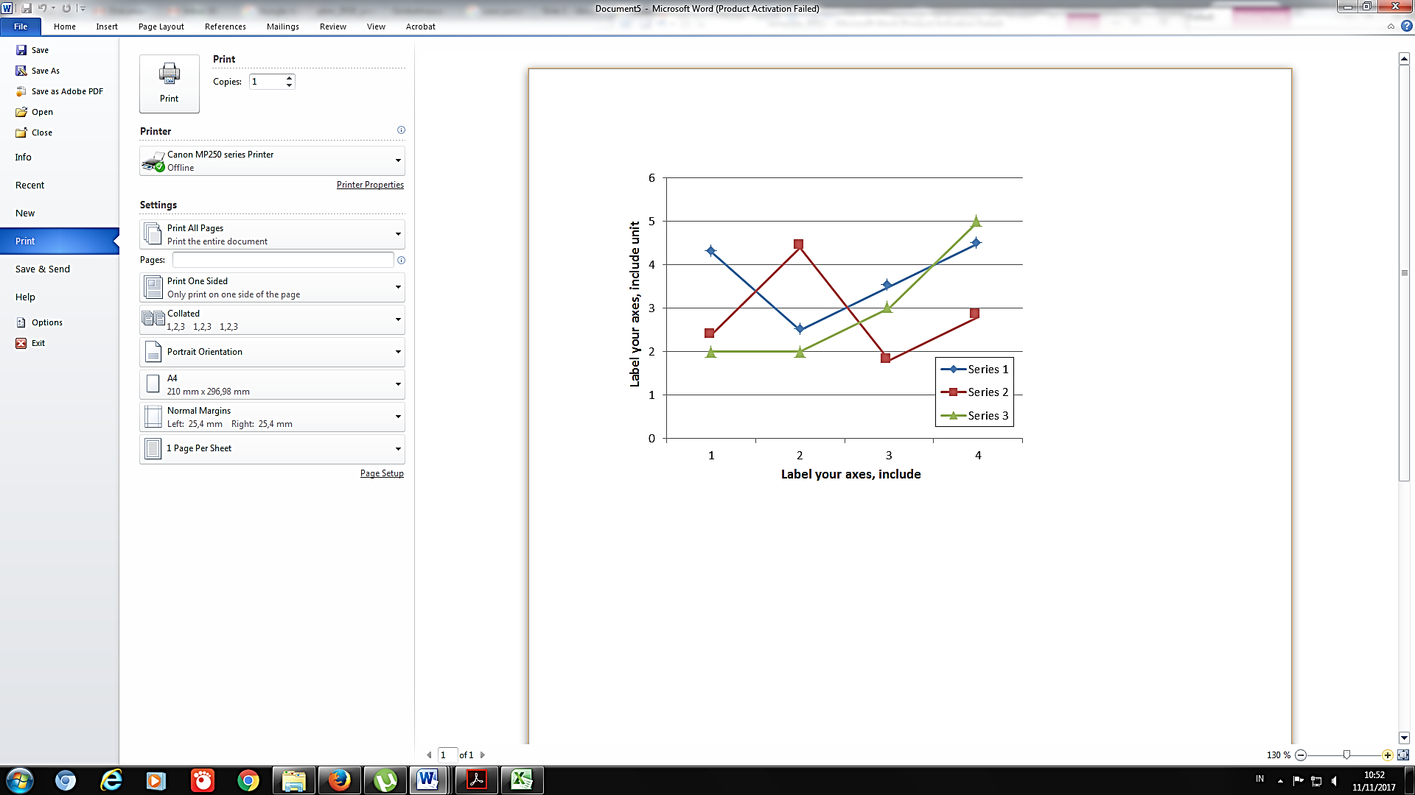
Fig. 1. A sample line graph using colors which contrast well both on screen and on a black-and-white hardcopy

- Figures and Tables
Figures and tables must be centered in the column. Large figures and tables may span across both columns. Any table or figure that takes up more than 1 column width must be positioned either at the top or at the bottom of the page.
Graphics may be full color. All colors will be retained on the CDROM. Graphics must not use stipple fill patterns because they may not be reproduced properly. Please use only SOLID FILL colors which contrast well both on screen and on a black-and-white hardcopy, as shown in Fig. 1.

Fig. 2 shows an example of a low-resolution image which would not be acceptable, whereas Fig. 3 shows an example of an image with adequate resolution. Check that the resolution is adequate to reveal the important detail in the figure.
Please check all figures in your paper both on screen and on a black-and-white hardcopy. When you check your paper on a black-and-white hardcopy, please ensure that:
- the colors used in each figure contrast well,
- the image used in each figure is clear,
- all text labels in each figure are legible.
- Figure Captions
Figures must be numbered using Arabic numerals. Figure captions must be in 8 pt Regular font. Captions of a single line (e.g. Fig. 2) must be centered whereas multi-line captions must be justified (e.g. Fig. 1). Captions with figure numbers must be placed after their associated figures, as shown in Fig. 1.



Fig. 2 Example of an unacceptable low-resolution image



Fig. 3 Example of an image with acceptable resolution
- Table Captions
Tables must be numbered using uppercase Roman numerals. Table captions must be centred and in 8 pt Regular font with Small Caps. Every word in a table caption must be capitalized except for short minor words as listed in Section III-B. Captions with table numbers must be placed before their associated tables, as shown in Table 1.
- Page Numbers, Headers and Footers
Page numbers, headers and footers must not be used.
- Links and Bookmarks
All hypertext links and section bookmarks will be removed from papers during the processing of papers for publication. If you need to refer to an Internet email address or URL in your paper, you must type out the address or URL fully in Regular font.

- Equations
Equations should be placed flush-left with the text margin. Equations are centered and numbered consecutively starting from 1 as follows
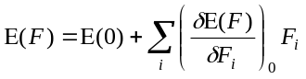 (1)
- References
The heading of the References section must not be numbered. All reference items must be in 10 pt font. Please use Regular and Italic styles to distinguish different fields as shown in the References section. Number the reference items consecutively in square brackets (e.g. [1]).
When referring to a reference item, please simply use the reference number, as in [2]. Do not use “Ref. [3]” or “Reference [3]” except at the beginning of a sentence, e.g. “Reference [3] shows …”. Multiple references are each numbered with separate brackets (e.g. [2], [3], [4]-[6]).
Examples of reference items of different categories shown in the References section include:
- example of a book in [1]
- example of a book in a series in [2]
- example of a journal article in [3]
- example of a conference paper in [4]
- example of a patent in [5]
- example of a website in [6]
- example of a web page in [7]
- example of a databook as a manual in [8]
- example of a datasheet in [9]
- example of a master’s thesis in [10]
- example of a technical report in [11]
- example of a standard in [12]
- CONCLUSIONS
The paper will not be reformatted, so please strictly keep the instructions given above, otherwise it will be returned for improvement. Please upload your paper in DOC file through the Conference website under Paper Submission menu.

AI Usage Statement
In preparing this article, the author used [name of AI tool] to [describe the purpose of use, e.g., grammar checking and language editing]. All AI output has been reviewed, verified, and edited by the author. The author is solely responsible for the content, accuracy, interpretation, and conclusions of the article. AI Use Declaration: The author declares that no generative AI was used in the preparation, analysis, interpretation of data, or writing of this article.

Author Contribution Statement
For research articles with several authors, a short paragraph specifying their individual contributions must be provided. The following statements should be used “Conceptualization, X.X. and Y.Y.; methodology, X.X.; software, X.X.; validation, X.X., Y.Y. and Z.Z.; formal analysis, X.X.; investigation, X.X.; resources, X.X.; data curation, X.X.; writing—original draft preparation, X.X.; writing—review and editing, X.X.; visualization, X.X.; supervision, X.X.; project administration, X.X.; funding acquisition, Y.Y. All authors have read and agreed to the published version of the manuscript.” Authorship must be limited to those who have contributed substantially to the work reported

Funding Statement
A Funding Statement is a section in a scientific publication or research report that explains the source of funding used to support the research or project. This statement aims to ensure transparency about who provided the funding and whether there are any potential conflicts of interest related to the funding. Common Elements in a Funding Statement: 1) Funding Source: Identifies the agency, organization, or individual who provided the funding. 2) Grant or Funding Number: Includes the reference number for the funding, if applicable. 3) Scope of Funding: Describes which aspects of the research or project were supported by the funding (e.g., laboratory costs, data collection, or publication). 4) Conflict of Interest Disclosure: If the funding source has a vested interest in the research outcomes, this should be disclosed.
Examples of a Funding Statement: a) "This research was funded by the Ministry of Education under Grant No. 12345." b) "The authors received funding from the National Science Foundation to support data collection and analysis (Grant No. NSF-98765)." d) "No external funding was received for this study."
Ethical Compliance
All procedures performed in studies involving human participants were in accordance with the ethical standards of the institutional and/or national research committee and with the 1964 Helsinki Declaration and its later amendments or comparable ethical standards.
Data Access Statement
A Data Access Statement is a section in a scientific publication or research report that explains how the data used or generated in the study can be accessed by readers or other researchers. This statement aims to promote transparency, support research reproducibility, and comply with open access policies, where applicable.
Common Elements in a Data Access Statement:
- Data Location: Specifies where the data is stored, such as in online repositories (e.g., Zenodo, Dryad, or institutional repositories).
- Access Instructions: Provides information on how to access the data, such as direct links, DOI (Digital Object Identifier), or contact details.
- Data Availability: Indicates whether the data is publicly accessible, available upon request, or restricted due to ethical, legal, or privacy considerations.
- Data Licensing: If the data is open, specifies the applicable license (e.g., Creative Commons).
Examples of Data Access Statements:
- Open Data:
  - "The data supporting this study are openly available in Zenodo at [DOI:10.xxxx/zenodo.xxxx]."
- Restricted Data:
  - "The data that support the findings of this study are available upon request from the corresponding author. Due to privacy concerns, the data are not publicly available."
- No Data Available:
  - "No datasets were generated or analyzed during the current study."
- Conditional Access:
  - "The data supporting this study are available under restricted access and can be obtained upon reasonable request to the corresponding author and with the permission of the ethics committee."
Purpose of a Data Access Statement:
- Reproducibility: Enables other researchers to replicate or verify the findings.
- Collaboration: Encourages further collaboration by sharing data.
- Compliance: Adheres to policies of funding agencies or journals that require open access to data.

Conflict of Interest Declaration
The authors declare that they have no affiliations with or involvement in any organization or entity with any financial interest in the subject matter or materials discussed in this manuscript.

ACKNOWLEDGEMENTS
Author thanks .... in most cases, sponsor and financial support acknowledgments.
REFERENCES [use APA style]
- Metev, S. M., & Veiko, V. P. (1998). Laser assisted microtechnology (2nd ed., R. M. Osgood, Jr., Ed.). Berlin, Germany: Springer-Verlag.
- Breckling, J. (Ed.). (1989). The analysis of directional time series: Applications to wind speed and direction (Vol. 61). Berlin, Germany: Springer.
- Zhang, S., Zhu, C., Sin, J. K. O., & Mok, P. K. T. (1999). A novel ultrathin elevated channel low-temperature poly-Si TFT. IEEE Electron Device Letters, 20(11), 569–571.
- Wegmuller, M., von der Weid, J. P., Oberson, P., & Gisin, N. (2000). High resolution fiber distributed measurements with coherent OFDR. In Proceedings of ECOC’00 (paper 11.3.4, p. 109).
- Sorace, R. E., Reinhardt, V. S., & Vaughn, S. A. (1997). High-speed digital-to-RF converter. U.S. Patent 5,668,842.
- The IEEE website. (2002). Retrieved from http://www.ieee.org/
- Shell, M. (2002). IEEEtran homepage on CTAN. Retrieved from http://www.ctan.org/tex-archive/macros/latex/contrib/supported/IEEEtran/
- Motorola. (1996). FLEXChip Signal Processor (MC68175/D).
- Opto Speed SA. (n.d.). PDCA12-70 data sheet. Mezzovico, Switzerland.
- Karnik, A. (1999). Performance of TCP congestion control with rate feedback: TCP/ABR and rate adaptive TCP/IP (Master’s thesis). Indian Institute of Science, Bangalore, India.
- Padhye, J., Firoiu, V., & Towsley, D. (1999). A stochastic model of TCP Reno congestion avoidance and control. University of Massachusetts, Amherst, MA. CMPSCI Technical Report 99-02.
- IEEE. (1997). Wireless LAN Medium Access Control (MAC) and Physical Layer (PHY) Specification (IEEE Std. 802.11).

